Name: Akash Arjun Sawant
Student ID: AF05009971
Batch code: ANP-D1396

Day 2 Lab

Assignment 1. Create a simple webpage using HTML to create your resume. The page should use various text elements to show different types of formatted text. Also use unordered list <ul> to organize information within each section. Use <style> tags for styling.

Code:

<!DOCTYPE html>
<html lang="en">
<head>
<meta charset="UTF-8" />
<meta name="viewport" content="width=device-width, initial-scale=1.0" />
<title>My Resume</title>

<style>
body{
background-color: #f0f0f0;
}
div {
font-family: Arial, sans-serif;
background-color: white;
margin: 40px;
border: 5px solid #ccc;
border-radius: 20px;
padding: 40px;
max-width: 700px;
margin-left: auto;
margin-right: auto;
}
h1 {
text-align: center;
color: #222;
padding-bottom: 10px;
}
h2 {
color: #004080;
border-bottom: 2px solid #ccc;
padding-top: 15px;
padding-bottom: 10px;
}
p,
li {
font-size: 16px;
color: #333;
}
a {
color: #0066cc;
text-decoration: none;
}
a:hover {
text-decoration: underline;
}
ul {
list-style-type: disc;
padding-left: 20px;
}
b {
color: #000;
}
</style>
</head>
<body>
<div>
<h1>Akash Sawant</h1>
<br />
<p>
<b>Email:</b>
<a href="mailto:sawantakash106@gmail.com">sawantakash106@gmail.com</a>
<b> | GitHub:</b>
<a href="https://github.com/akashsawantwebdev" target="_blank"
>github.com/akashsawantwebdev</a
>
</p>

<h2>Professional Summary</h2>
<p>
I am a motivated and enthusiastic Web Developer fresher with hands-on
experience in building responsive web applications through personal and
academic projects. Skilled in full-stack development using HTML, CSS,
JavaScript, React, Node.js, PHP, MongoDB, MySQL and Java. I possess strong problem-solving, analytical, and reasoning
abilities, along with effective communication skills and teamwork.
</p>

<h2>Technical Skills</h2>
<ul>
<li><b>Frontend:</b> HTML5, CSS3, JavaScript, React</li>
<li><b>Backend:</b> Node.js (with Express.js), Java, , PHP</li>
<li><b>Database:</b> MySQL, MongoDB</li>
<li><b>Tools & Others:</b> Git, Command Line, AWS Cloud Computing</li>
</ul>

<h2>Education</h2>
<ul>
<li><b>Master of Computer Applications (MCA):</b> Mumbai University, Pursuing</li>
<li><b>Bachelor of Science in Information Technology (BSc IT):</b> Mumbai University, Completed</li>
</ul>

<h2>Certifications</h2>
<ul>
<li><b>Web Development with PHP:</b> Anudip Foundation</li>
<li><b>JavaScript Essential, AWS Cloud Computing, Java Programming:</b> LetsUpgrade.in</li>
<li><b>Python Programming, Command Line and Git:</b> Progate.com</li>
</ul>

<h2>Languages</h2>
<ul>
<li><b>English</b></li>
<li><b>Marathi</b></li>
<li><b>Hindi</b></li>
</ul>

<h2>Availability</h2>
<ul>
<li><b>Immediate</b></li>
</ul>
</div>
</body>
</html>

Output:

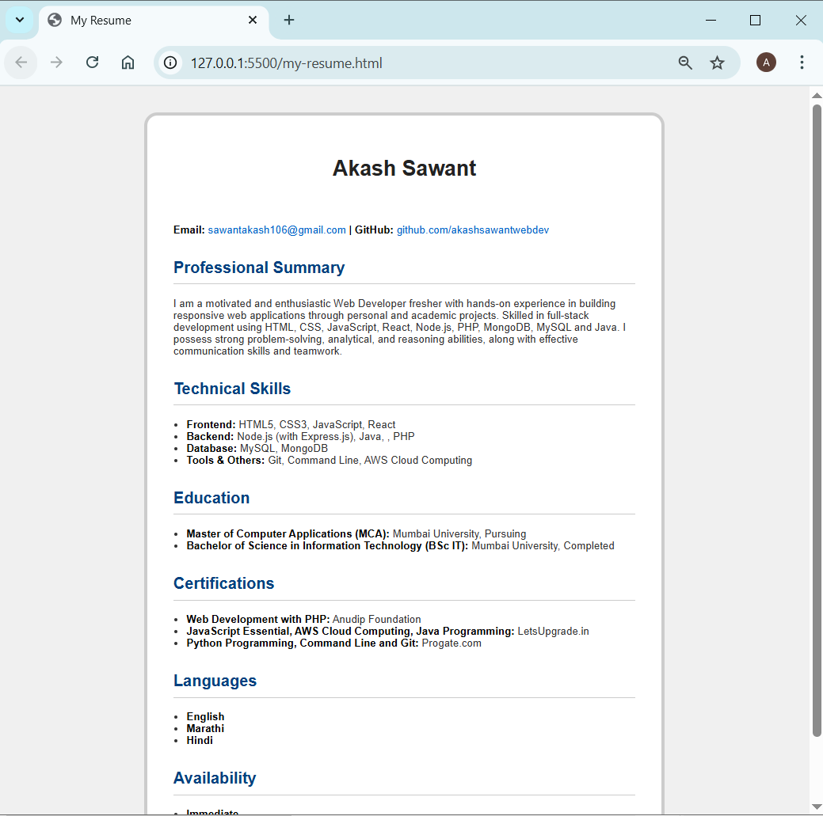

Assignment 2. Create an HTML page to list different types of motor vehicles available in the Indian market with a brief description for each of them. Use <style> tags for styling.
Use definition list for the description.

Code:

<!DOCTYPE html>
<html lang="en">
<head>
<meta charset="UTF-8" />
<meta name="viewport" content="width=device-width, initial-scale=1.0" />
<title>Motor Vehicles in the Indian Market</title>

<style>
body{
background-color: #f0f0f0;
}
div {
font-family: Arial, sans-serif;
background-color: white;
margin: 40px;
border: 5px solid #ccc;
border-radius: 20px;
padding: 40px;
max-width: 750px;
margin-left: auto;
margin-right: auto;
}
h1 {
background-color: #ff4d4d;
color: white;
text-align: center;
padding: 15px;
border-radius: 10px 10px 0 0;
}
dt {
color: #cc0000;
font-weight: bold;
font-size: 18px;
margin-top: 15px;
padding-bottom: 10px;
}
dd {
margin-left: 20px;
color: #333;
font-size: 16px;
padding-bottom: 15px;
}
</style>
</head>
<body>
<div>
<h1>Motor Vehicles in the Indian Market</h1>
<br>

<dl>
<dt>Scooter</dt>
<dd>
A scooter is a two-wheeled motor vehicle with a step-through frame and a
platform for the rider's feet. It is known for its ease of use and fuel
efficiency.
</dd>

<dt>Motorcycle</dt>
<dd>
A motorcycle is a two-wheeled motor vehicle with a more upright seating
position and typically a manual transmission. It is popular for its
performance and versatility.
</dd>

<dt>Hatchback</dt>
<dd>
A hatchback is a type of car with a rear door that opens upwards,
providing access to a cargo area. It is known for its compact size and
practicality.
</dd>

<dt>Sedan</dt>
<dd>
A sedan is a four-door passenger car with a separate trunk for cargo. It
is often chosen for its comfortable and spacious interior.
</dd>

<dt>SUV (Sports Utility Vehicle)</dt>
<dd>
An SUV is a larger vehicle designed for off-road capabilities and
versatility. It is popular for its high driving position and ample cargo
space.
</dd>

<dt>MUV (Multi Utility Vehicle)</dt>
<dd>
An MUV is a vehicle designed to transport passengers and cargo. It often
features a spacious interior and is suitable for family use.
</dd>

<dt>Electric Vehicle</dt>
<dd>
An electric vehicle is powered by one or more electric motors, using
energy stored in rechargeable batteries. It is chosen for its
eco-friendly and sustainable features.
</dd>
</dl>

</div>
</body>
</html>

Output:

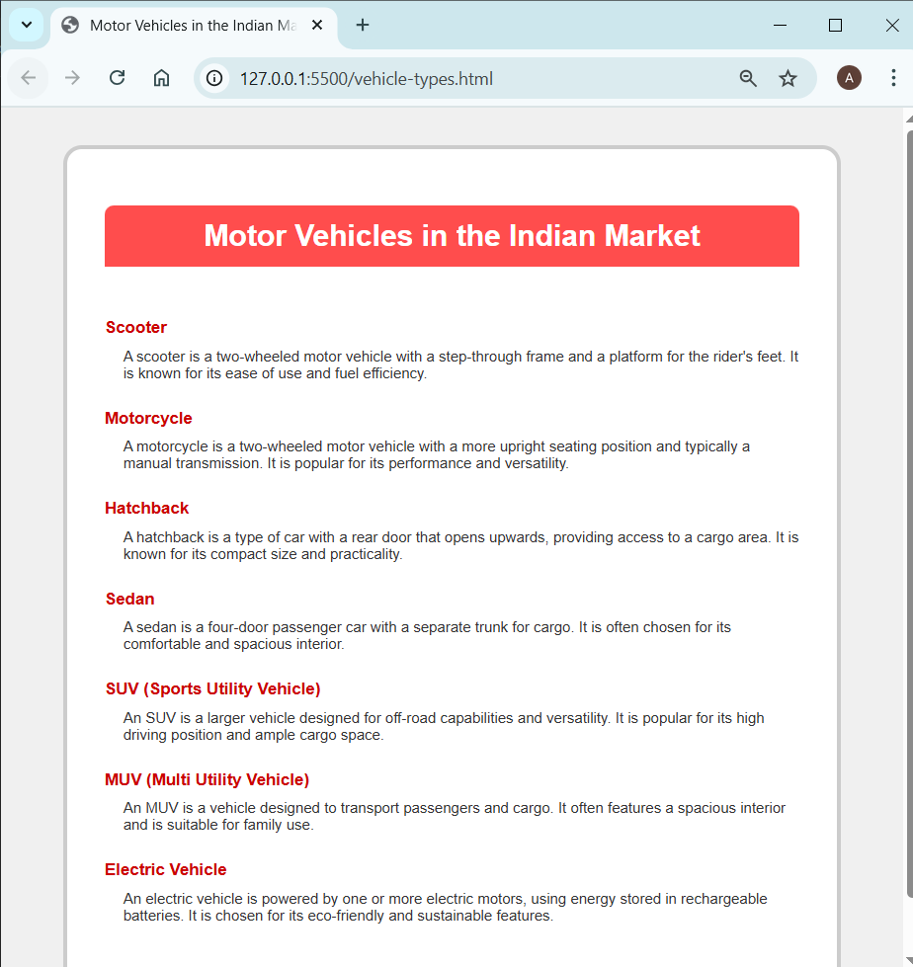

Assignment 3. You are developing a home page for an online music store. Create an HTML
page that can be used as a starting page for the users. Use <style> tags for styling.

Code:

<!DOCTYPE html>
<html lang="en">
<head>
<meta charset="UTF-8" />
<meta name="viewport" content="width=device-width, initial-scale=1.0" />
<title>Sky Music Company</title>

<style>
body {
font-family: Arial, sans-serif;
background-color: #f5f8ff;
margin: 0;
padding: 0;
}
header {
background-color: #007bff;
color: white;
text-align: center;
padding: 20px;
}
h1 {
margin: 0;
font-size: 28px;
}
h3 {
font-weight: normal;
}
section {
background-color: white;
margin: 20px;
padding: 15px;
border-radius: 8px;
box-shadow: 0 0 5px rgba(0, 0, 0, 0.1);
}
footer {
background-color: #007bff;
color: white;
text-align: center;
padding: 10px;
font-size: 14px;
}
ul {
list-style-type: disc;
margin-left: 20px;
}
a {
color: #0000ee;
text-decoration: none;
}
a:hover {
text-decoration: underline;
}
</style>
</head>
<body>
<header>
<h1>Sky Music Company</h1>
<h3>Connecting Cultures Through Music</h3>
</header>

<section>
<h2>Featured Indian Album: "Raga Reverie"</h2>
<p>
Embark on a musical journey through the rich and soulful sounds of
Indian classical music with our featured album "Raga Reverie."
</p>
</section>

<section>
<h2>Explore Genres</h2>
<ul>
<li><a href="#">Indian Classical</a></li>
<li><a href="#">Western Classical</a></li>
<li><a href="#">Bollywood</a></li>
<li><a href="#">Pop</a></li>
<li><a href="#">Jazz</a></li>
<li><a href="#">Rock</a></li>
</ul>
</section>

<section>
<h2>Featured Artists</h2>
<ul>
<li>Ravi Sitar Maestro</li>
<li>Emily Violin Virtuoso</li>
<li>Amit Bollywood Beats</li>
<li>Sophia Jazz Sensation</li>
</ul>
</section>

<section>
<h2>Contact Us</h2>
<p>Email: info@skymusic.com</p>
<p>Phone: +91-9876543210</p>
</section>

<footer>© 2025 Sky Music Company. All rights reserved.</footer>
</body>
</html>

Output:

